

Department of Computer Science & Engineering

Project Report
Group - 1

Course Title : Digital Signal Processing Lab
Course Code : CSE - 416
Submitted By | Submitted To
Session : Spring-2022  Semester : 8th  Section :C  Batch : 29th | Susmita Paul  Lecturer,  Rokaiya Tasnim  Lecturer, (On Probation)  Varendra University  Department of CSE
  ID | Name
  221311089 | MD SAFWAN NESHAT RANGAN
  221311092 | MD. MAHMUDUL HASAN
  221311096 | MD. SOLAIMAN HOSSAIN SHAHI
  221311111 | M. IFTAKHAR ALOM

Project Title: Design and Implementation of a Lowpass/Highpass Filter for Enhancing the Quality of Speech Signal Captured in Noisy Environment.

Theory:
Speech signals are often contaminated with unwanted noise, especially low-frequency disturbances like electrical hum, wind, or engine sounds. These can hinder clarity and intelligibility. To address this, digital signal processing techniques such as filtering are used.
A high-pass Butterworth filter allows high-frequency components to pass while attenuating low-frequency noise. The Butterworth filter is particularly chosen for its smooth frequency response in the passband and no ripples.

Objective:
To design and implement a real-time system in MATLAB that:
- Applies a high-pass filter to remove noise from speech signals.
- Allows users to play both original and filtered audio.
- Provides real-time waveform visualization to analyze filtering effects.

Tools Used:
- Software: MATLAB
- Functions: audioread, butter, filter, sound, audioplayer, timer, plot, uicontrol, figure
- Filter Type: Butterworth high-pass filter

Procedure:
Step 1: Load Audio Signal
- Load an .mp3 speech file using audioread().
- Extract sampling frequency and time vector.
Step 2: Design High-Pass Filter
- Choose a cutoff frequency (e.g., 1000 Hz) to remove low-frequency noise.
- Use a 6th-order Butterworth high-pass filter via butter().
Step 3: Filter the Signal
- Apply the filter using filter() to the audio data.
- Normalize the signal to avoid distortion during playback.

Step 4: Implement GUI
- Create a MATLAB GUI using figure and uicontrol.
- Include buttons for:
  - Playing original audio
  - Playing filtered audio
  - Pausing playback
Step 5: Real-Time Visualization
- Use audioplayer and timer to visualize the waveform during playback.
- Continuously update plot window based on current playback position.

Code Summary (Main Function):
1  2  3  4  5  6  7  8  9  10  11 | function real_time_audio_viewer()  filePath = 'C:\Users\snran\Desktop\G-Drive\8th\CSE - 416 Digital Signal Processing Lab\DSP-Projects\beep.mp3'  ;  [x, fs] = audioread(filePath);  fc = 1000;  order = 6;  [b, a] = butter(order, fc/(fs/2), 'high');  y = filter(b, a, x);  y = y / max(abs(y));  end

Discussion:
The application demonstrates the effectiveness of high-pass filtering for improving speech signals affected by low-frequency noise.
Users can interactively switch between original and filtered versions to observe the enhancement. The real-time plot helps visualize amplitude changes and waveform characteristics, aiding educational and research purposes.

Conclusion:
This project successfully implemented a high-pass Butterworth filter in MATLAB to clean noisy speech signals. With a user-friendly interface and real-time waveform visualization, the system effectively demonstrates how digital filtering can enhance audio quality in noisy environments.

Project Output’s :
Statup window:
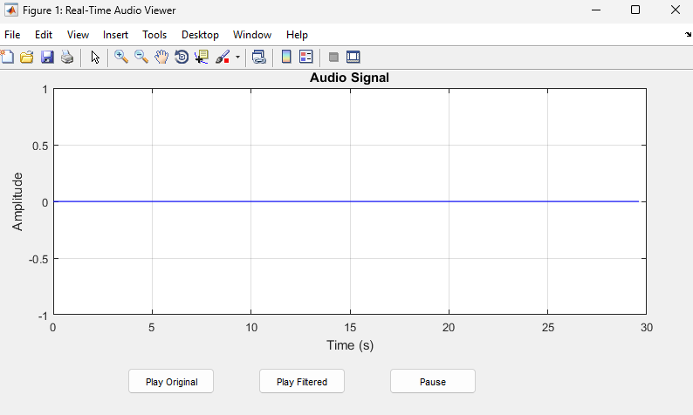

Play Orginal audio:
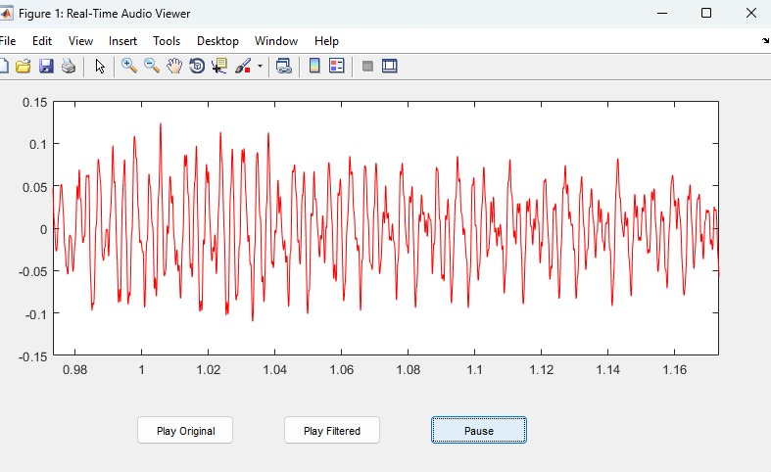

Play Filtered Audio :


